Overview of the Objectives, Processes and Products of the COHYST Project

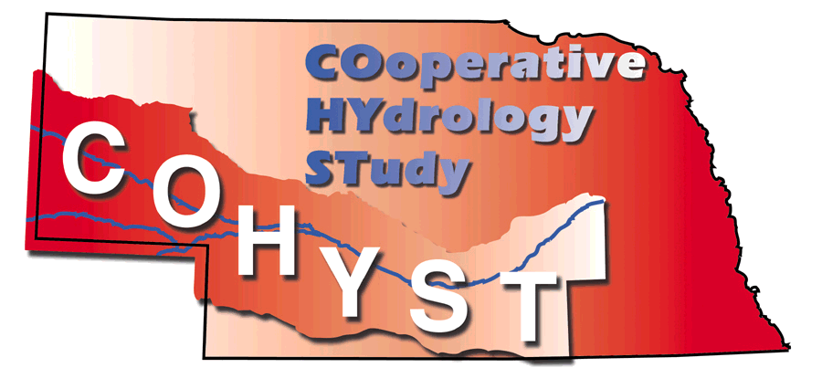

By

Technical Committee

September 21, 2004
Final Draft
Funding provided by

Table of Contents

List of table and figures 2

Introduction 3

Statement of purpose 3

Study objectives 3

Study process 4

Establish Study Scope 4

Evaluate Existing Information and Tools 5

Develop Information and Data into Databases 13

Develop and Calibrate Groundwater Models 23

COHYST products 26

List of Figures

Figure 1. COHYST study area and model units 5
Figure 2. Hydrostratigraphic Units 12
Figure 3. Location of Irrigation wells and Testholes 13
Figure 4. Contour Map of Base of Aquifer 13
Figure 5. Hydraulic Conductivity Map of Unit 2 14
Figure 6. Stream gage Location used in Base Flow Analysis 15
Figure 7. Stream Location Map for Bed Conductance Measurements 16
Figure 8. COHYST Soils Map 17
Figure 9. 1982 CALMIT irrigated land Buffalo County 18
Figure 10. 1997 CALMIT irrigated land Buffalo County 18
Figure 11. 2001 CALMIT irrigated land Buffalo County 19
Figure 12. COHYST Weather Station map for Crop Water Use analysis 20

Figure 13. Topographic Regions map by CSD 21
Figure 14. Flowchart for Process of Estimating Pumpage and Recharge 22

Introduction

This document presents an overview of the work completed and products produced for the Nebraska COoperative HYdrology STudy (COHYST). COHYST was initiated by state and local agencies (sponsors) and is supported by municipalities, environmental organizations, and water user organizations (partners). The study sponsors have developed and signed an Interagency Cooperative Agreement (ICA) to administer and carry out the financial responsibilities of this Nebraska Environmental Trust (NET) project. Funds were requested and granted from the NET fund to supplement financial support and in-kind services from the sponsors and partners.

The Cooperative Hydrology Coordinating Team (Coordinating Team) was formed by representatives of the study sponsors and partners. They direct the study. The Coordinating Team interviewed three firms and hired one to provide a Senior Hydrologist to participate in selecting technologies and reviewing work and work products throughout the study. Parsons Inc., was selected, teamed with Hemenway Groundwater Engineers.

A workshop was held March 17th & 18th, 1998 in Lincoln, NE for the Coordinating Team members and the Senior Hydrologist to scope out the study. The agenda for the workshop was divided into five sessions, which addressed a series of questions:
Session 1: What do we want from the Cooperative Hydrology Study?
Session 2: What information do we have to work with?
Session 3: What are our choices for decision support tools?
Session 4: What tools and information do we need?
Session 5: So how do we get there?

The result of the workshop was the establishment of the Technical Committee made up of staff from the Sponsors agencies. This Committee developed a Work Plan dated 7/10/98. The Work Plan contains the following Statement of Purpose and Study Objectives.

Statement of Purpose

The study is a cooperative effort to improve understanding of the hydrological and geological conditions in the Platte Basin in Nebraska upstream of Columbus, Nebraska. A group of Nebraska interests have joined together as sponsors and partners to develop scientifically supportable hydrologic databases, analyses, modeling, and other information which when completed will:

1. Assist Nebraska to meet her obligations under a separate three-state Cooperative Agreement (CA),
2. Assist the Platte River Natural Resources Districts (NRD's) to provide appropriate regulation and management,
3. Provide Nebraskans with a basis to develop policy and procedures related to ground water and surface water,
4. Help Nebraskans analyze proposed activities of the CA and/or other programs in Nebraska.

Study Objectives

The Coordinating Team decided an water resources Decision Support System (DSS) was needed to accomplish the above purposes. Development of the DSS for the Platte River Basin in Nebraska above Columbus required that the Coordinating Team develop and implement the following objectives:
- Collect existing data and models.
- Place data into an appropriate database.
- Review existing data and models to identify data gaps.
- Collect supplemental data as necessary to be added to the database.
- Develop linked, regional models to cover the Platte basin in Nebraska above Columbus.
- Establish credibility of the data, database and models.
- Design and develop a geographical user interface and GIS-based Internet link to the data and models.
- Put models to use in accomplishing purposes described above.

Study Process

Establish Study Scope

Based on the tasks outlined by the work plan one of the first items of work was to establish study area. The study area was established based on review of the regional groundwater level contour maps, flow data on rivers and tributaries that have groundwater base flow, and available aquifer information presented in United States Geological Survey (USGS) Publications and the University of Nebraska Conservation & Survey Division (CSD) reports. The COHYST study area established is shown in figure 1. The study area covers all or parts of 47 counties and covers approximately 18.7 million acres. Land use information for 1997 estimated 3.8 million acres are irrigated agricultural, 4.5 million acres are dryland agricultural, 9.1 million acres are hay and rangeland agricultural, and 1.4 million acres are in other use (roads, lakes, urban, farmsteads, etc). The area delineated by this work was adopted as the boundary for the regional groundwater models and all databases including GIS coverages and tabular information.

The Technical Committee selected a groundwater flow computer program to be applied in developing and calibrating a regional groundwater flow system. The USGS Modular three- dimensional finite-difference groundwater flow program (MODFLOW) developed by McDonald and Harbaugh (1988) was it. Supporting software for preprocessing and post processing information for MODFLOW utilizing Microsoft Windows 2000 based operating system were reviewed and the Groundwater Model System (GMS) software sold by BOSS International was selected.

One of the study parameters established was to use Nebraska State Plane NAD 83 as the projection system with units in feet. A quality assurance plan and metadata standard were developed for the study to set controls and guidelines on data and model development.

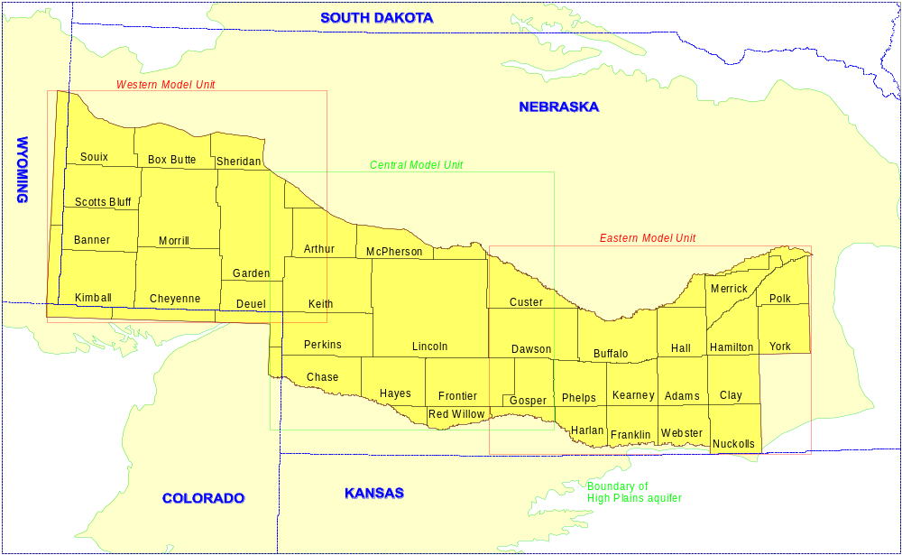
Figure 1. COHYST study area and model units.
Evaluate Existing Information and Tools

Existing Database Systems

In reviewing existing databases for the DSS system the requirements established include:

1. The need for security and integrity so the data cannot be deleted or altered with by unauthorized persons;
2. Easy write-access by those with authorization;
- Easy, but read-only, access by everyone else;
4. Supporting descriptions of the data in standard "metadata" format; and
5. The ability to create a history of changes to the data or date system.

The assumption throughout the planning process for the development of the Platte River Decision Support System (DSS) has been that the data will reside on the Nebraska Natural Resources Commission's computer system. The NDNR has both UNIX and Windows NT operating systems, and both can be accessed (read/write) by outside users.

In the UNIX environment, the DNR staff has most of its experience with the "INFO" part of ARC/INFO. So for this project, databases created for the UNIX environment are typically in GIS format which includes mapping features with database attributes related to the point, line or polygon items.

Developing databases in the Windows NT environment could have been handled by dBase, or Access. The DNR selected Microsoft Access as its database program because of the ease of use in developing databases and publishing this information on the Web.

Existing Ground Water Flow Studies

The following is an annotated list of past studies and models that were reviewed and inventoried to determine for each what data was used, what methodologies were employed, and whether the products could be incorporated in COHYST:

- Missouri River Basin Commission, 1976. Platte River Level B Study. This study was developed around the 1970’s level of land use, it estimated groundwater depletions base on predicted future growth, it evaluated surface water development projects and generated reports on hydrology, economics, etc.
- Upper Platte River Study, 1983. Included three reports one developed by USBR on surface and ground water operation hydrology, a second, by Geological Survey Professional Paper 1277, 1983. Study on river hydrologic and geomorphic studies, and a third by USFWS Ecology Study,1983. Area studied was Platte River Basin above Grand Island, NE.
- Missouri Basin States Association, 1983 – Hydrology Study developed ground water depletion estimates made using Jenkins SDF method, and used a study period 1944 to 1978.
- Central Platte NRD area groundwater modeling in1980’s. The original model developed by Peckenpaugh J.M. and Dugan J.T., 1983. Hydrogeology of Parts of The Central Platte and Lower Loup NRD’s. Water-Resources Investigations Report 83-4219. Revised by HDR, 1989; Revised and converted to MODFLOW by CH2M HILL, 1993.
- Tri-Basin NRD area groundwater modeling in 1980’s. Peckenaugh J.M. and Others, 1987 Hydrolgeology of the Tri-Basin and Parts of the Lower Republican and Central Platte NRD’s - Water Resources Investigation 87-4176; Finite Element Model.
- Twin Creek Area – University of Nebraska Conservation and Survey Division; Open File Report 96-206; MODFLOW Model.
- Platte/Republican Model - USGS/Conservation and Survey Division studies. Initial study by Conservation and Survey followed by USGS.
- Harza, 1993. Nebraska Public Power District Water Utilization Study for the Sutherland Project FERC 1835 - Operations and conservation study using USGS MODFLOW Model.
- Keasling Bob, 1975. A Digital Model of Conjunctive Use Irrigation in Dawson County – This groundwater model was developed as an UNL master’s student thesis and later used by Irrigation Districts to file for incidental groundwater recharge permits.
- Miller C.A., 1993 Modeling of the Kearney Well Field Using a Three-Dimensional Groundwater Model. This analysis was developed evaluate the Kilgore Island Water Supply for the City of Kearney. It is thesis report for a Master of Science degree.
- Nguyen Q.M. and Gilliland M.W., 1985 A Surface water – Groundwater Interaction Model for the Platte River Well Field of Grand Island by UNL Civil Engineering Department. This model used a 2D finite difference program developed by Prickett and Lonnquist. CPNRD, 1996. The Grand Island Well Field Model was reviesd to a 10 square mile groundwater model using MODFLOW for the inducted groundwater recharge permitting process of surface water.
- Upper Republican Model – Peckenpaugh J. M. and others, 1995 Simulated response of the High Plains aquifer to ground water withdrawals in the Upper Republican NRD, NE.
- Upper Big Blue River NRD modeling, Cady R.E. and Ginsberg M.H. 1979 Interpretive Study and Numerical Model of Hydrogeology Upper Big Blue NRD.
- Prairie Bend Unit Planning Report / DES Study by USBR, 1989. – The groundwater analysis in this planning study that determines future groundwater recharge needs in the Prairie Bend area was done with a version of the Prickett and Lonnquist ground water model called AQUSIM.
- Wood River Groundwater Recharge Demonstration by CPNRD and USBR, 1997. This demonstration project showed how Platte River water can be delivered into recharge basins to effectively replenish groundwater supply.
- Wesche T. A.,Skinner Q. D., and Hensezy R. J., 1994 Platte River Wetland Hydrology Study was develop by the Wyoming Water Research Center along the Central Platte River and monitored groundwater and surface water changes.

As shown by the above reports, ground water analyses and models have been developed, calibrated and applied over much of the State. A powerpoint presentation (June 2004) summarizing the history of modeling in Nebraska is available for viewing on the COHYST website.

The Platte River Level B Study 1976 showed a map for regions covered by groundwater models at that time. The Platte Level B study included coarse-grid models for the Elkhorn, Loup, Middle Platte, Twin Platte, and Lower Platte regions. An Upper Platte model was considered in the Level B study, but the reliability of the input data was so poor in that area that the development of a model was not considered practical.

The digital models used in the Level B analysis were developed to solve unsteady two-dimensional flow through an unconfined non-homogeneous aquifer and used node sizes of 2.5 X 2.5 miles. Among other applications, the models were used to estimate stream flow depletions due to estimates of future pumping development.

A study similar to the Platte River Level B ground water depletion work was completed as part of the Upper Platte River Study 1983 by DOI agencies. The USBR developed a series of AQUSIM ground water models for the Platte River above Columbus, NE using three-mile node spacing.

Significant additional modeling has been done in the Central Platte NRD area including the USGS 960-acre node model which was most recently updated by CH2M HILL to run in MODFLOW. Since it was originally developed it has been used for many purposes (CPNRD Groundwater Management Plan, Prairie Bend Project Planning, Dawson County Conservation Study, etc.)

A number of overlapping models have been developed ina areas south of the Platte River (Big Blue River, South Central Nebraska, Twin Platte/Middle Republican, and Upper Republican). Another model was developed for the Box Butte County area. All the models have been used for predictive purposes.

Contact Other Modelers for Ideas on Tools and Methods

This task has been ongoing throughout the study and was included to seek out experiences and new developments in developing and applying tools like MODFLOW to simulate groundwater - surface water interactions. Discussing and reviewing ideas with other modelers improved credibility and provided opportunity for avoiding pitfalls. A good example was the discussions with Modelers working on the Republican River Basin to develop a groundwater model on groundwater – surface water interactions for use in the Republican River Compact Agreement. Frequent contacts were made including a half-day information exchange.

Geologic Parameter Inventory and Investigation

The Technical Committee along with geologists and hydrogeologists made an inventory of the geology across the COHYST area from CSD and USGS publications. They evaluated and selected the method to be used in the DSS for defining the Hydrostratigraphic Units (model layers) that make up the aquifer of the COHYST area from the Platte River Basin above Columbus, NE to the state lines. The method for estimating the associated hydraulic parameters (hydraulic conductivity, specific yield, etc) for each unit was also selected. As the methods were developed, they were described in detail and included in the Hydrostratigraphic Units report.

Investigation of Methods for Estimating Net Recharge and Pumpage

A number of methods have been developed into models to simulate the rainfall-runoff-evapotranspiration-recharge processes that provide the vertical component of recharge/discharge needed in groundwater flow models. These existing methods and models were reviewed and evaluated for use in the COHYST effort. Three that were considered include:

1. USGS Method by Jon Peckenpaugh used in 1983 Central Platte NRD Model

In the 1983 USGS Water Resources Report 83-4219, the Potential Evapotranspiration (PET) Program and the Soil-Moisture Program are used to represent the movement of water in and through the soil zone. These programs require climatic, soil, and crop data to calculate both the amount of water that will pass through the soil zone to become recharge to the aquifer and the consumptive irrigation requirement, CIR, of crops. Cady and Peckenpaugh (1985) discuss the operational procedures and physical basis for these soil-zone programs. The PET and Soils Moisture Programs may be adapted to any of the potential model areas along the Platte River

- UNL Method by Dr. Derrel Martin

The CROPSIM soil water balance model was developed to aid in the prediction of evapotranspiration, deep percolation, and runoff that occurs from a range of cropped and
naturally vegetated systems. The model consists of a Fortran program that reads numerous
input files containing information on daily climate, tillage practices, soils, and farming practices and outputs soil water balance information for various time periods.

This model was originally develop and used for the Nebraska vs Wyoming lawsuit on the North Platte River and is described in the report, "Irrigation Water Requirements and On-Farm Water Use for the North Platte River Valley From Whalen, Wyoming to Lewellen, Nebraska”. In this report the UNL method analyzed the amount of water consumed as evapotranspiration and the amount of return flow as either runoff or deep percolation from irrigated farms in the North Platte River Valley from 1941 through 1994

3. US Bureau of Reclamation - BASIN Program to Compute Basin Water Use 1981

The USBR BASIN program computes on a monthly time step:
- Irrigation farm delivery requirements,
- Project diversion requirements,
- Groundwater recharge, or
- Basin outflow depending upon the purpose of the study.

The program will also compute streamflow depletions or net change in groundwater recharge due to a change in cropping patterns or irrigated acreage.

Evapotranspiration may be computed by one of four methods: (1) Jensen-Haise 1970.
(2) Jensen-Haise 1966. (3) Jensen-Haise 1964. (4) Blaney-Criddle (TR-21).

Groundwater discharge is computed by methods developed by R.E. Glover. Monthly rainfall infiltration curves were developed from monthly rainfall-runoff data collected by the ARS-USDA at Hastings, Nebraska. These curves should be usable across the Platte River Basin area.

Data needs were restricted to readily available data. However some judgement values will be required. The program uses monthly data and will handle up to 50 years of record.

A monthly moisture budget of the crop root zone is used to determine when recharge will take place and the amount. The moisture budget is also used to determine the number of irrigation applications required to maintain soil moisture above a pre-determined level. Inflow to the root zone is from precipitation and applied irrigation water. Outflow is to the atmosphere by evapotranspiration and to the water table by gravity drainage.

Net Recharge and Pumpage Method selected for COHYST

Net- recharge and pumpage can be computed a number of ways based on evaluations of these methods. Many of the existing methods use monthly inputs, which brings up some concerns when trying to estimate surface water-ground water interaction along the Platte River. Based on precipitation and ground water level data collected along the Platte River the rate of recharge is very rapid thus the accounting of the soil moisture budget may need to be done on a daily bases to properly account the volume of recharge that is occurring.

Peckenpaugh's method was developed in the mid-to-late 70s. The BASIN method was also developed in the mid-to-late 70’s, and Martin's was developed in the mid-to-late 90s so it takes advantage of newer technology and information. Martin's method was first developed on a smaller area of western Nebraska and eastern Wyoming and takes advantage of similar latitude conditions and assumptions.

It was decided the development of a net-recharge algorithm for COHYST needed to be done using a water budget approach on a daily time frame so outputs can be summarized into groundwater model time steps. It was also decided the method or analyses selected should be similar to the existing Peckenpaugh or BASIN approach so that crop consumptive use and net irrigation requirement are used to compute ground water pumpage. The following steps were taken to develop net-recharge, and net pumpage :

1. Completed a thorough evaluation of existing methods and contracted with Dr. Martin at UNL Agricultural Engineering Department to help make application of the Crop Simulation Model CROPSIM to the COHYST area.
- Determine inputs and computations necessary to use CROPSIM outputs (crop ET, rainfall runoff, deep percolation, net irrigation, etc) to develop net recharge, and pumpage inputs for the ground water models.

An Evaluation was made of Software to be used in GIS applications and windows based development for MODFLOW

This evaluation was completed by trying a number of vendor’s software packages. The final selection made was ERSI ARC- INFO or ARC-View as the GIS platform and Groundwater Management System GMS as the MOFLOW software.

Developed information and data into usable Databases

In this task, the Technical Committee and Senior Hydrologist defined the list of data needed in the database for ground water analyses. The databases developed are stored as spatial data and time series data. The following is list of the spatial data that was acquired for the study region shown on Figure 1:

- Geology (Elevations of top and bottom of all hydrostratigraphic units)
- Aquifer properties (Hydraulic conductivity and specific yield)
- Existing aquifer test data and results
- Land surface topography
- Groundwater level data (Contour maps over time and depth to water)
- River data (Flow data, cross sections, bed conductivity, quality data, rating data)
- Soils (Classification and engineering properties)
- Land use by type for past and present, irrigated vs. non-irrigated, groundwater irrigated vs. surface water irrigated
- Climatological data (Temperature, precipitation, wind, solar, ---daily)
- Consumptive use (Trees, grass, corn, soybeans, etc.)
- Groundwater recharge (Soil moisture budget method, canals and reservoirs seepage, and induced recharge)
- Groundwater pumping (Past to present 1950 -1998)
- Estimates of and measurements of canal carriage losses
- Estimates of base flow by river reach and by tributaries

Some of the data was developed as spatial data with no time element, while some of the spatial data change with time and were compiled for a series of years or other time steps.

The time series data is information collected at a fixed location on an hourly, daily or monthly basis. The following is a list of the time series data needed in the database:

- Stream flow and stage records at all gaging stations (daily)
- Reservoir storage levels (monthly)
- Climatological data (Temperature, precipitation, wind, solar radiation, and pan evaporation)
- Pumping volumes computed by the soil moisture budget method
- Recharge computed by the soil moisture budget method
- Ground water level data (seasonal)
- Canal diversions and farm delivery (monthly)
- Gaged return flow records

Geology, Hydraulic Properties, and Aquifer Test Results

The development of aquifer-related data are described in the report titled “Cooperative Hydrology Study Hydrostratigraphic Units and Aquifer Characterization Report”. Based on the spatial distribution and thickness of the geologic materials that make up the aquifer within the COHYST area, hydrostratigraphic units were defined and mapped. The units were to develop model layers that represent major geologic changes in the aquifer system. The block diagram shown in Figure 2 was developed to portray the ten hydrostratigraphic units as they were defined for use in the COHYST Study. The geologic interpolation of the units was made from approximately 6500 geologic logs that cover the study area (see Figure 3). The geologic logs include logs from test holes drilled by the Conservation and Survey Division (CSD) and drillers logs from the installation of irrigation wells. The spatial dataset of unit elevations was then used to build contour maps of the top or bottom of each unit (see Figure 4) and to build a multi-layer dataset for input to the groundwater models.

The hydraulic properties for the Hydrostratigraphic Units were estimated using test-hole geologic log descriptions of the sand, silt, clay, or gravel material. The frequent adjectives like fine, very fine, coarse, etc that make up the descriptions also get used in estimating hydraulic properties. The properties estimated include hydraulic conductivity and specific yield. A utility program called Geoparm was developed to read the logs and interpolate the properties by hydrostratigraphic unit. The interpolation is done based on values developed by E.C. Reed and R. Piskin from UNL Conservation and Survey Division. The resulting output is a spatial dataset for the 2000+ test-holes. This spatial dataset of hydraulic conductivity and specific yield at the testhole locations was interpolated to develop spatial model input data for the grid over the study area. As an example, Figure 5 shows a spatial Hydraulic Conductivity map for hydrostratigraphic unit 2 (alluvial sand and gravel).
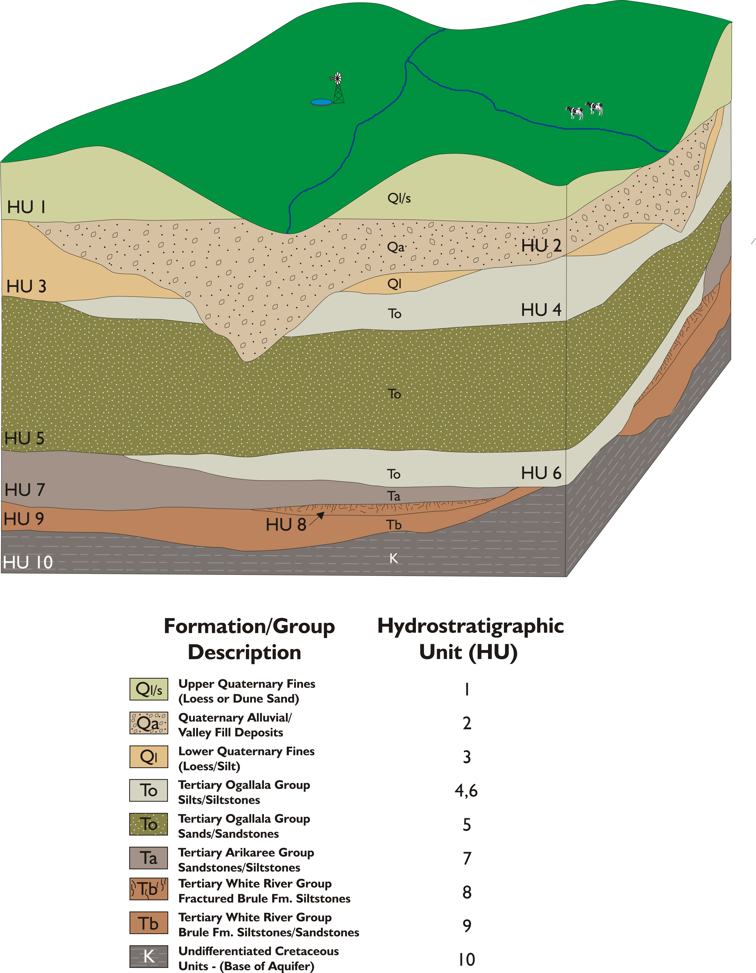
Figure 2. Pictorial drawing of Hydrostratigraphic Units in COHSYT area
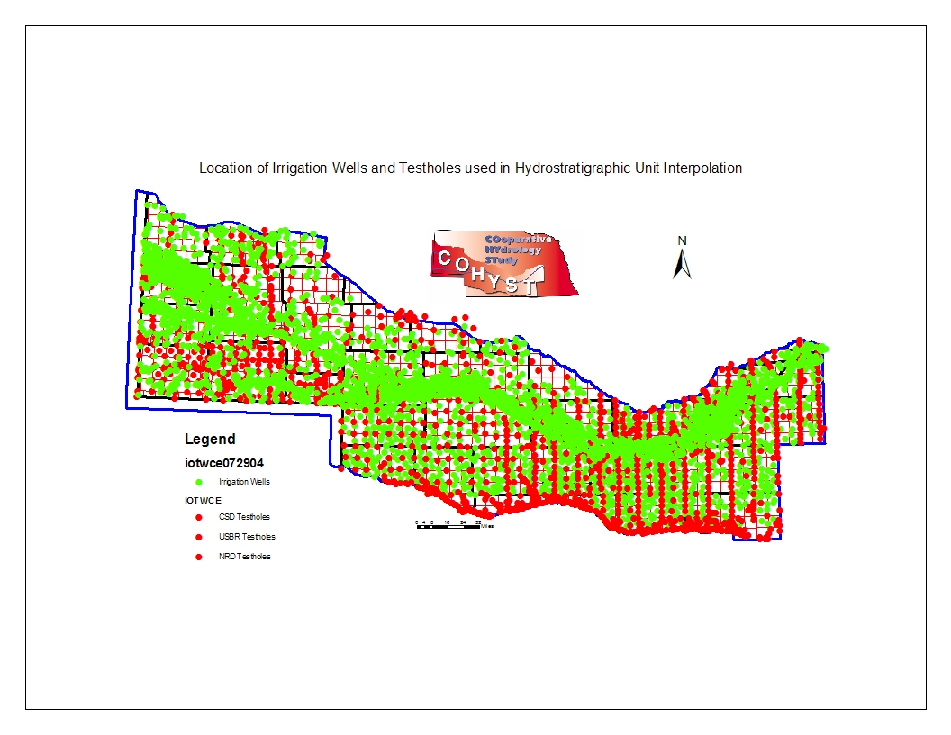
Figure 3. Map of test-hole and well location
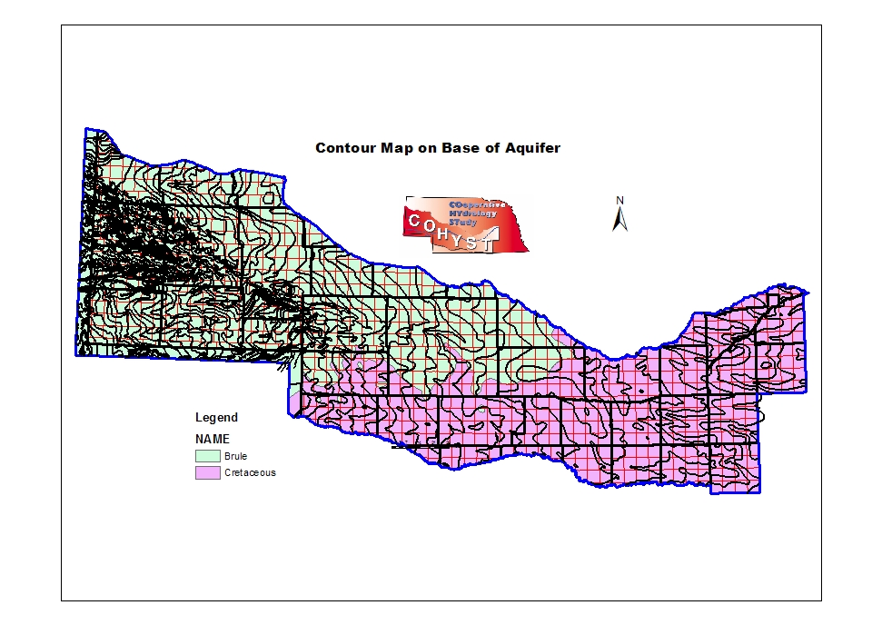
Figure 4. Hydrostratigraphic Unit contour map for base of aquifer unit 9 or 10

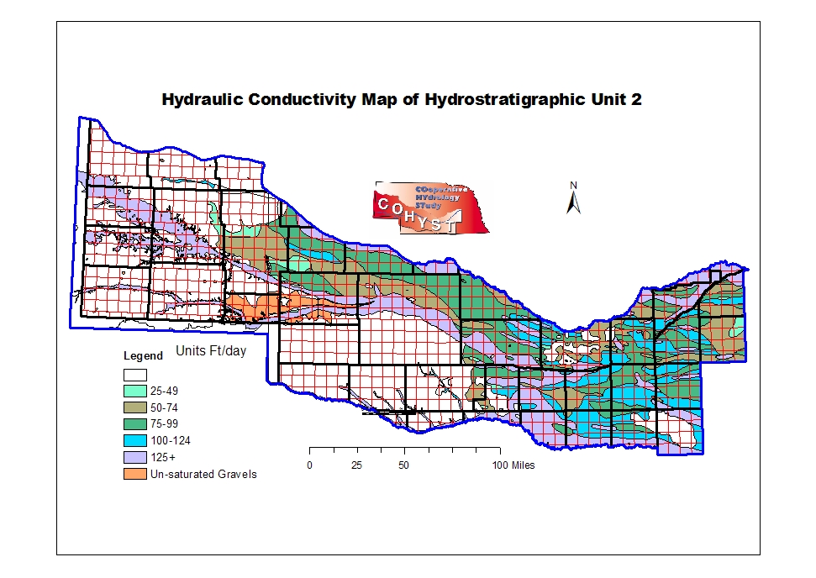

Figure 5. Map of Hydraulic Conductivity for selected ranges in hydrostratigraphic unit 2

Land Surface Topography

Several land surface GIS datasets were aquired for use in developing other COHYST elevation based datasets, such as outcropping areas of the Hydrostratigraphic Units or land surface elevations of irrigation wells. Land surface also was needed to implement algorithms that determined water table evapotranspiration ET. These datasets were developed from the USGS digital elevation models.

Groundwater data (Elevation and Depth to Water)

Groundwater level data was compiled and used for model calibration. Calibration datasets were developed with water table elevations measured during the 1945 to 1955 period for the pre-groundwater development period, and water table elevation changes between 1950 and 1997 for the development period. These datasets were assembled from historic data that has been collected by the USGS, CSD, or NRD and recorded in the USGS database. As part of the COHYST work, over 2000 observation wells have been surveyed to 1 centimeter accuracy.

River data (Discharges, Cross Sections, Bed Conductivity, & Stage data)

River flow data was used to develop base-flow calibration data at 28 river gage locations and 52 tributaries (see Figure 6). The base-flow data was developed for the period of record at most stations that have long periods of flow data. The reports titled “Estimated Groundwater Discharge to Streams from High Plains Aquifer” for each of the model units describe the development and details of base-flow calibration data.

River stage data and flow measurement data were used to develop algorithms for estimating river stage over time and along the length of the river channels as input for the MODFLOW stream package.

River and tributary bed elevation were interpolated at equal intervals along the channels from USGS digital elevation model data.

River bed conductance had not been previously measured in the COHSYT area, so several studies were conducted by the USGS and UNL to measure riverbed conductance. One study titled “Comparison of Instream Methods for Measuring Hydraulic Conductivity in Sandy Streambeds” was published in Vol 39 No.6 Ground Water Nov- Dec 2001. A second report titled “Vertical Profiles of Streamdbed Hydraulic Conductivity Determined Using Slug Tests in Central and Western Nebraska” is USGS Water-Resources Investigations Report 01-4212. These studies along with some constant-head permeameter measurements and bed coring samples made on streams by COHYST modelers provided information about bed conductance across the COHYST study area (see Figure 8).
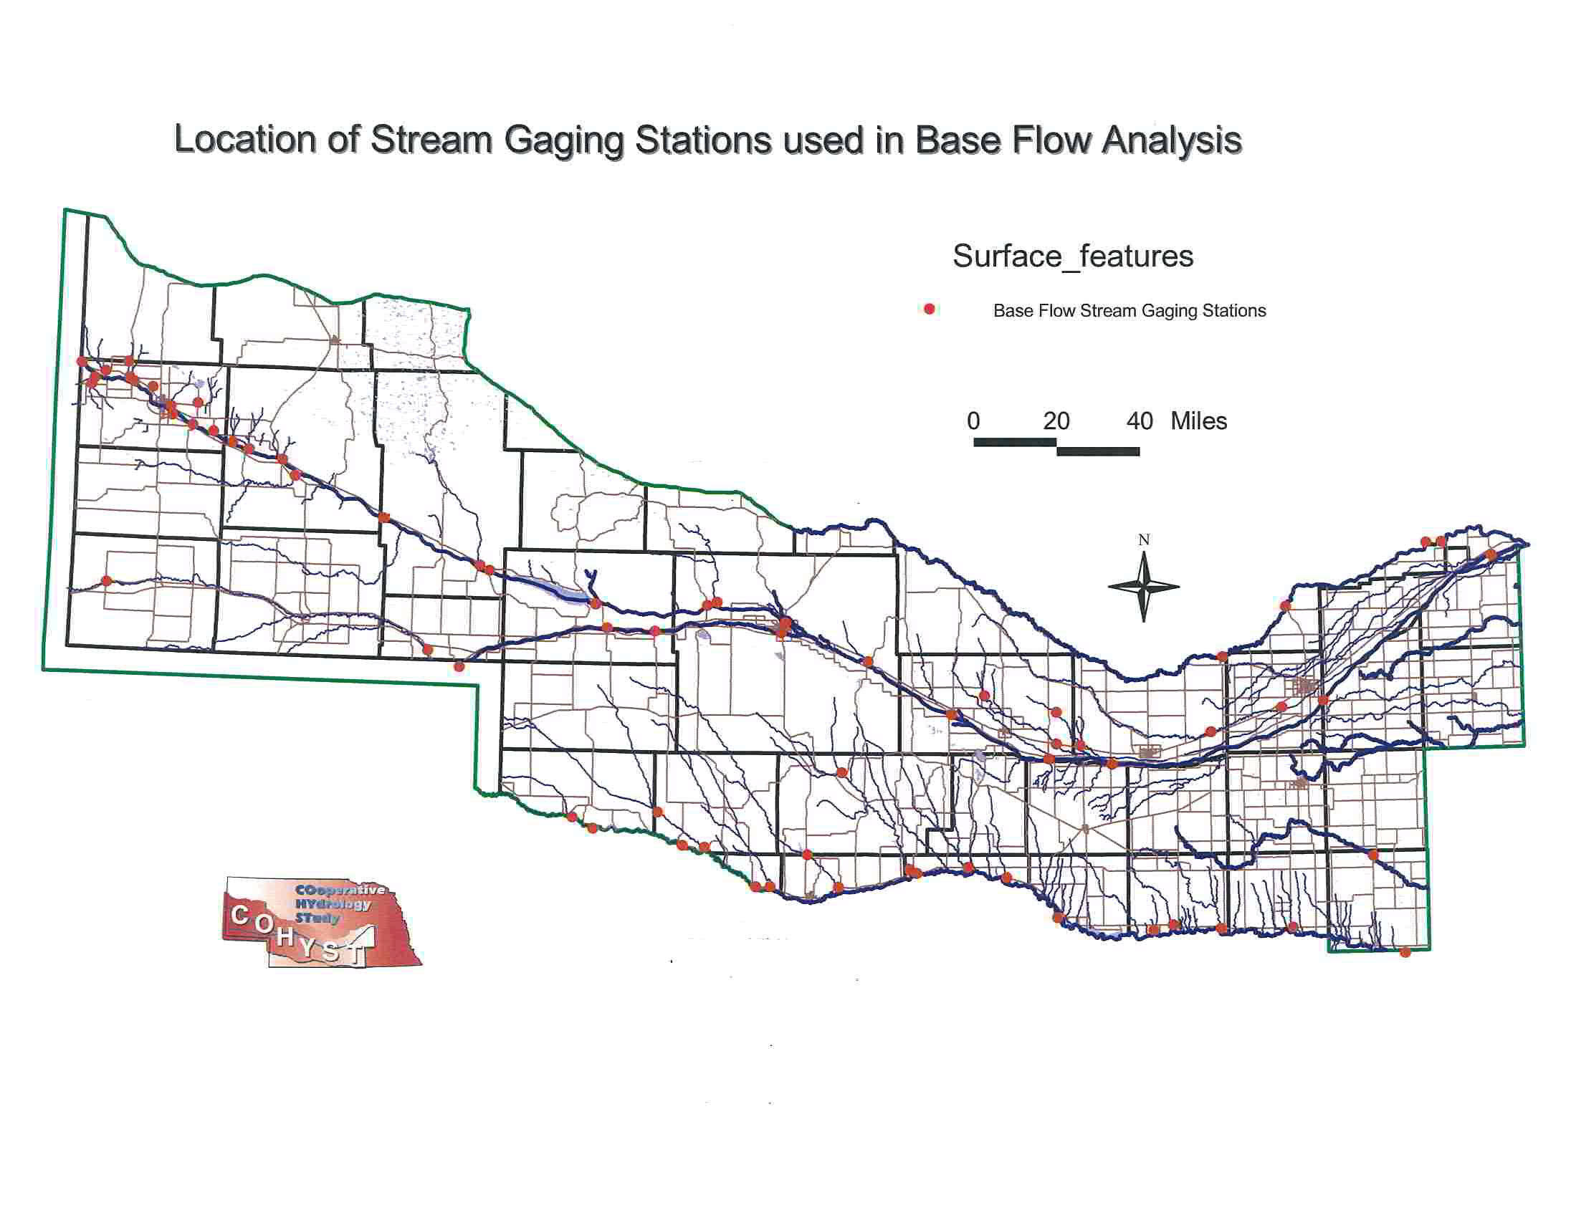
Figure 6. Stream gaging station location map
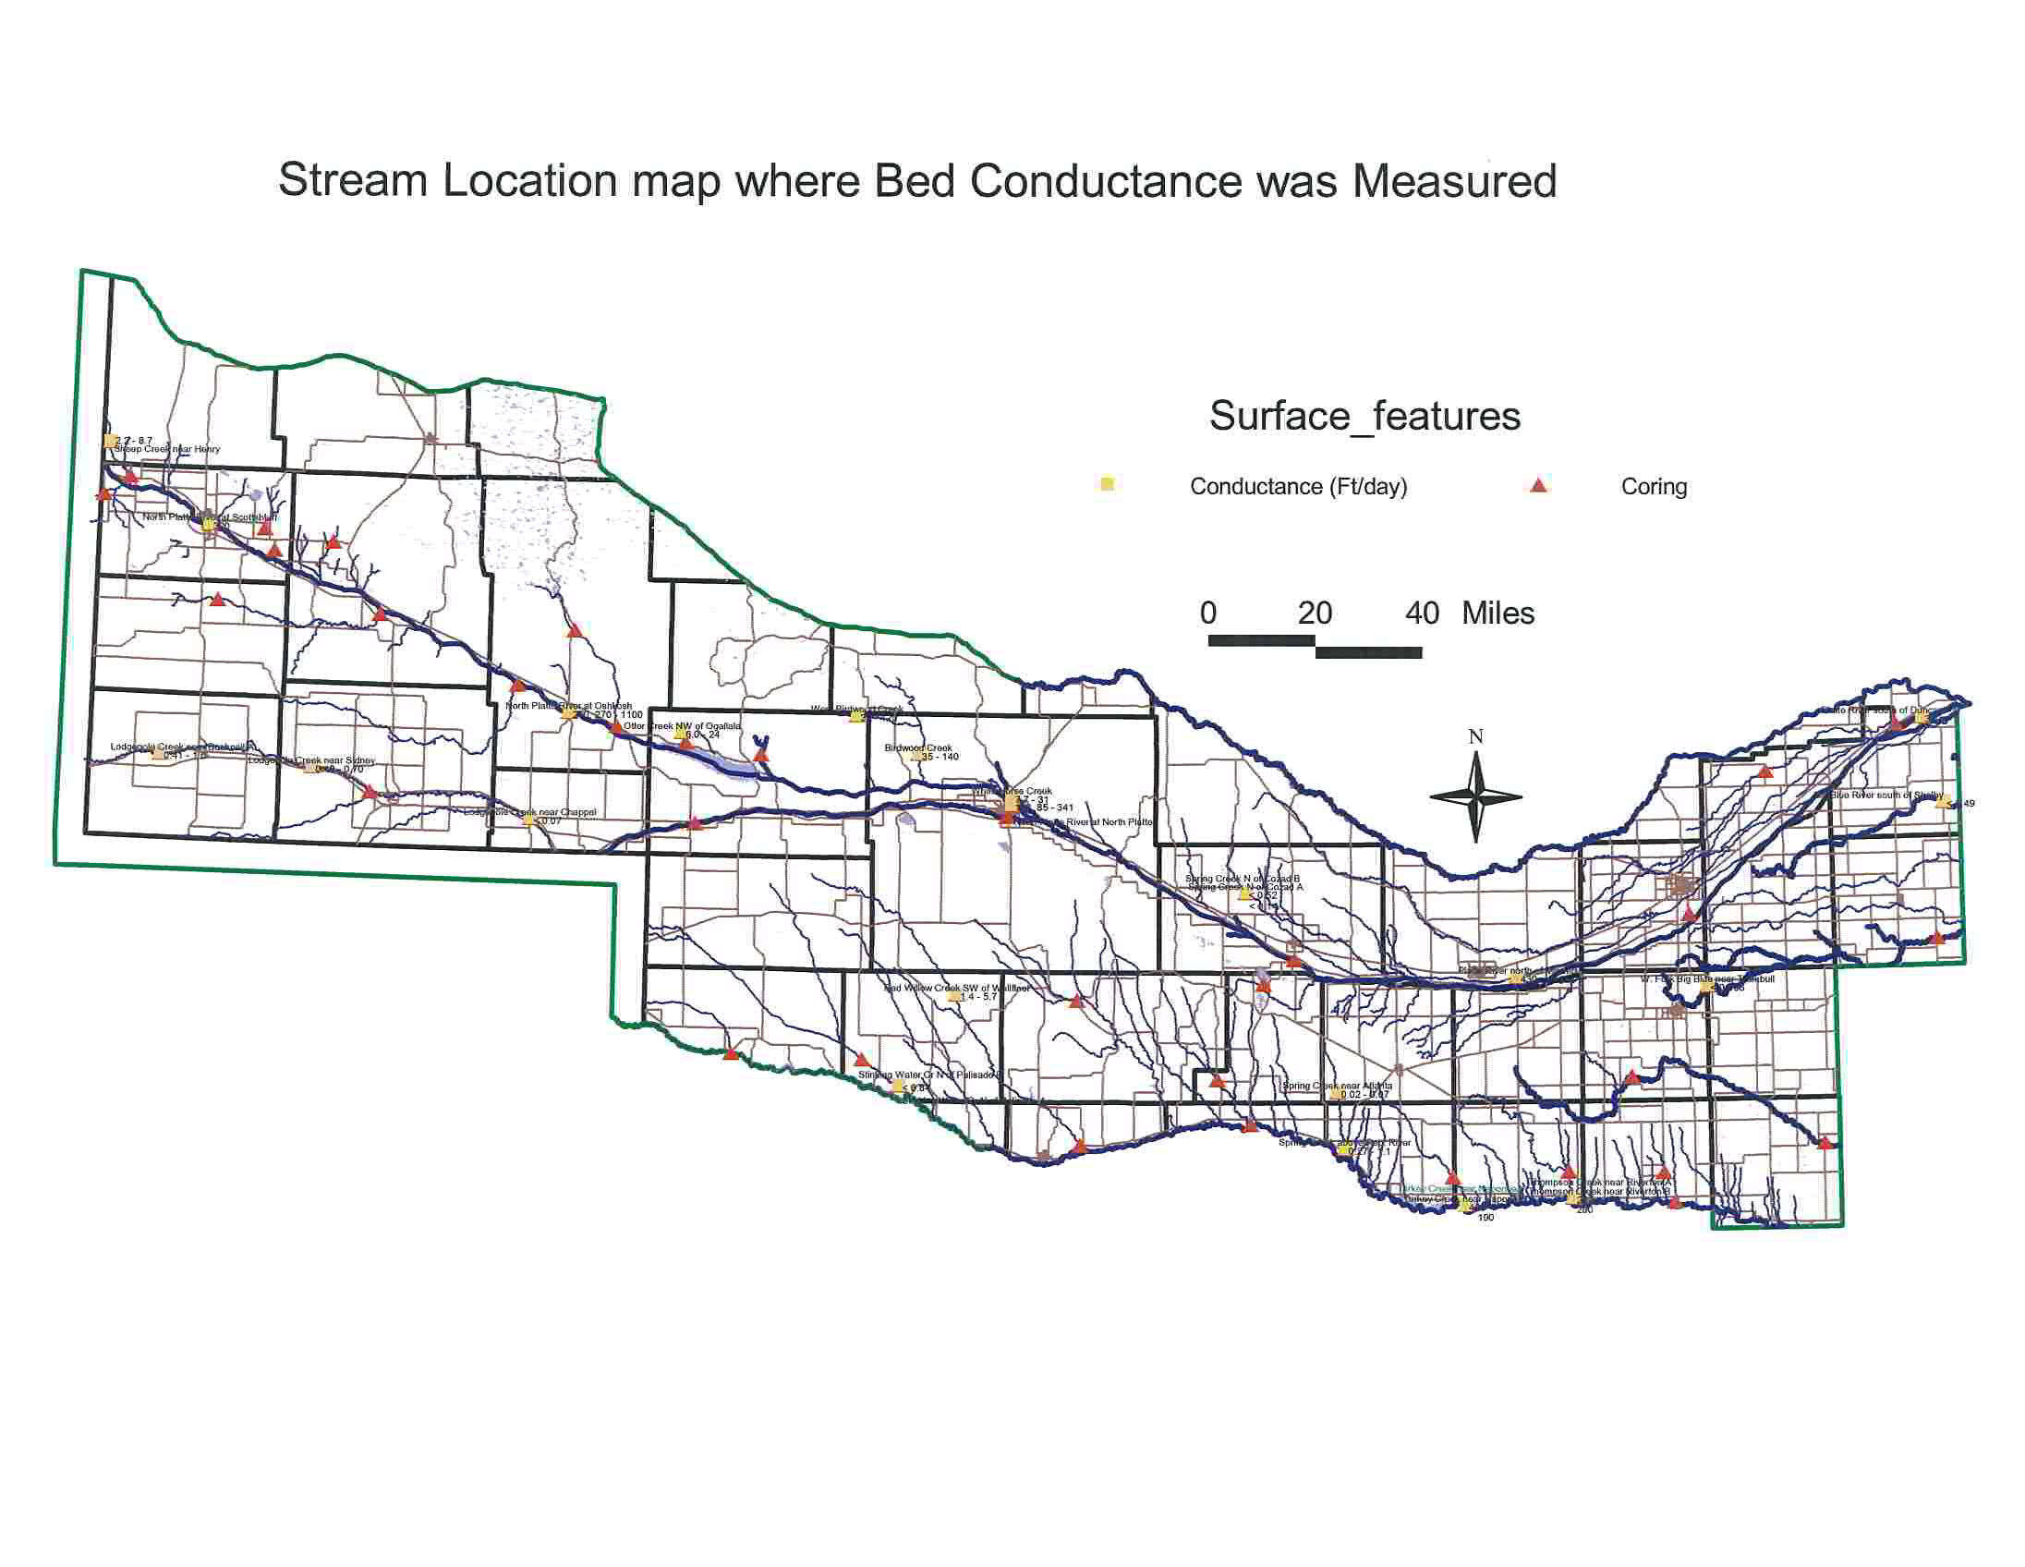
Figure 7. Location map were stream bed conductance was measured and coring samples collected

Soils (Classification and Engineering Properties)

Soils information in the COHYST study was used to estimate pumpage and recharge. Soil classifications for the study were taken from the USDA-NRCS State Soil Geographic STATSGO data-base and consolidated by soil characteristics as described by Dugan J.T. 1984 USGS Water Supply paper 2222. The consolidated soils database for the COHYST area was developed by the UNL Agricultural Engineering Department and mapped as shown in figure 8.
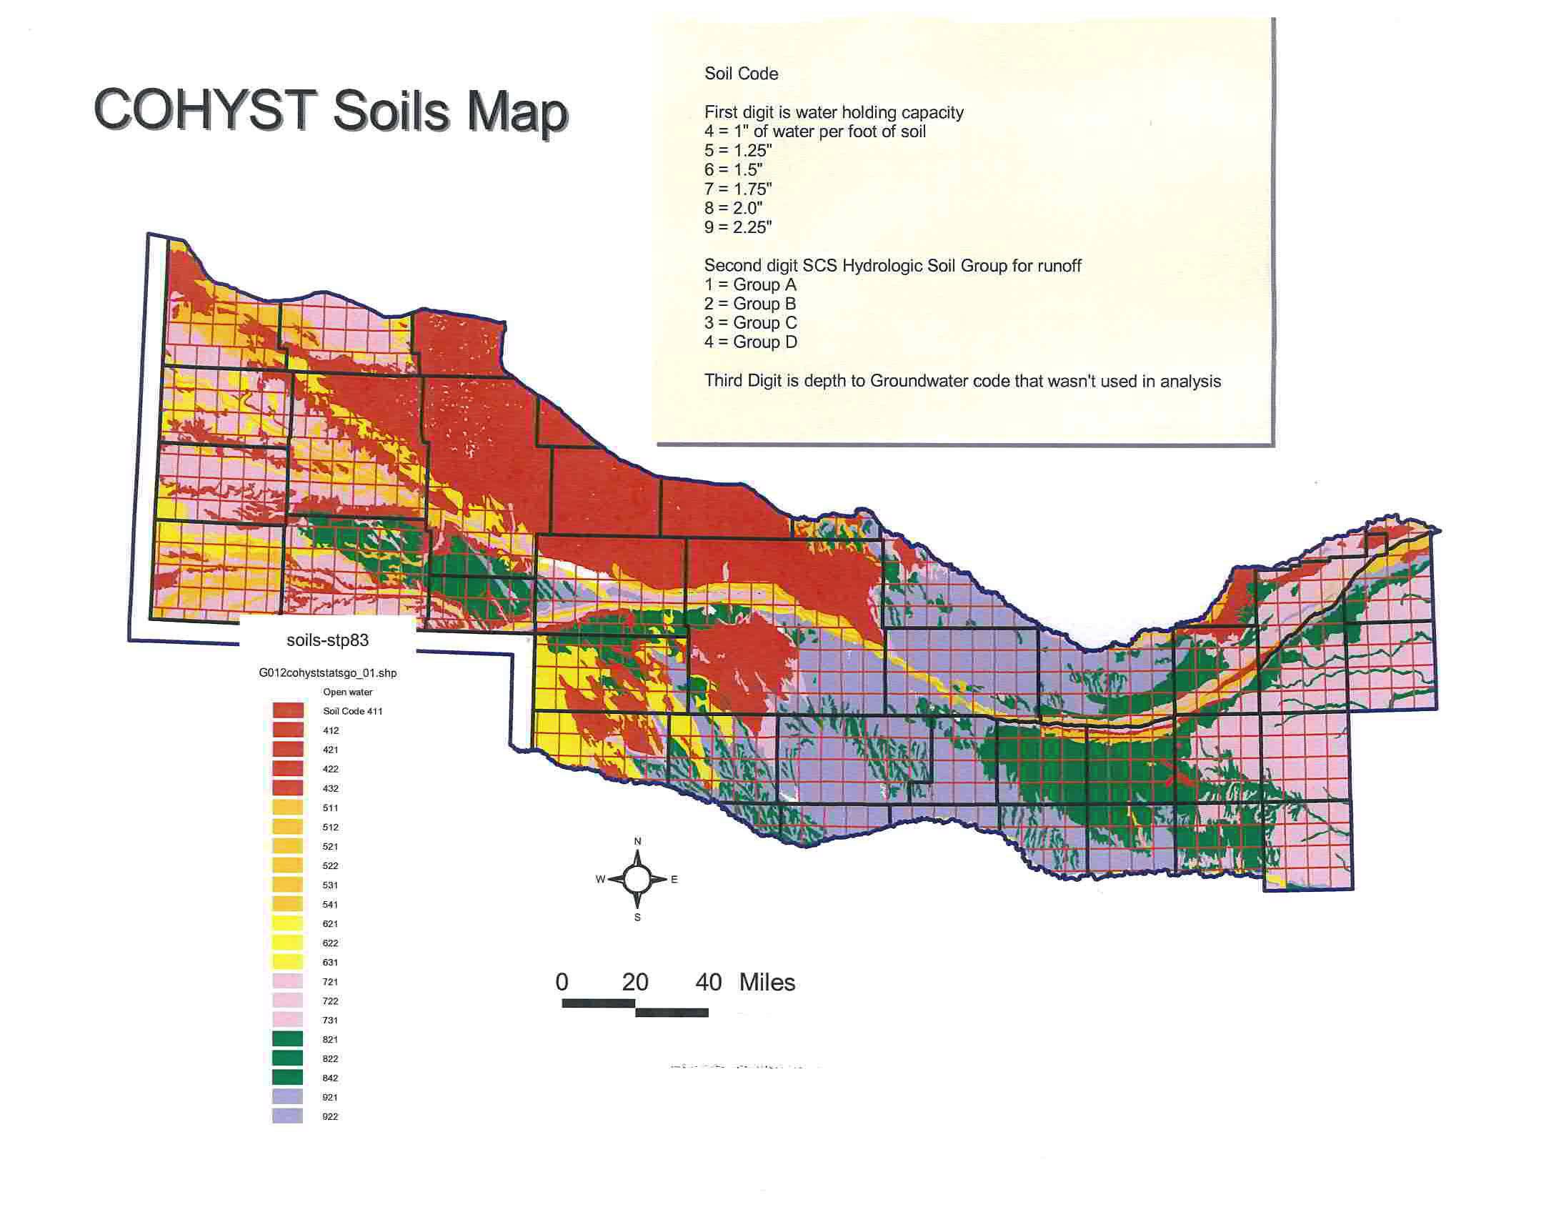
Figure 8. COHYST soils map delineated based on water holding capacity and hydrologic soil group

Land Use by Type for Past to Present, Irrigated vs. Nonirrigated , and Groundwater irrigated vs. Surface Irrigated

Land use data for the COHYST study was developed from two main sources: Census of Agriculture tabular data for the period 1950 to 1997 and spatial data developed by UNL-CALMIT for 1982, 1997, and 2001 using Landsat imagery. The spatial data from CALMIT distinguished 26 land use types for the COHYST area including irrigated and dryland crops. The 1997 spatial data was the first dataset developed and was used along with the Census of Agriculture data to develop a 1950 to 1997 spatial database for the COHYST area. Figures 9, 10, and 11 shows typical examples of the 1982,1997 and 2001 irrigated lands in a township of Buffalo county.

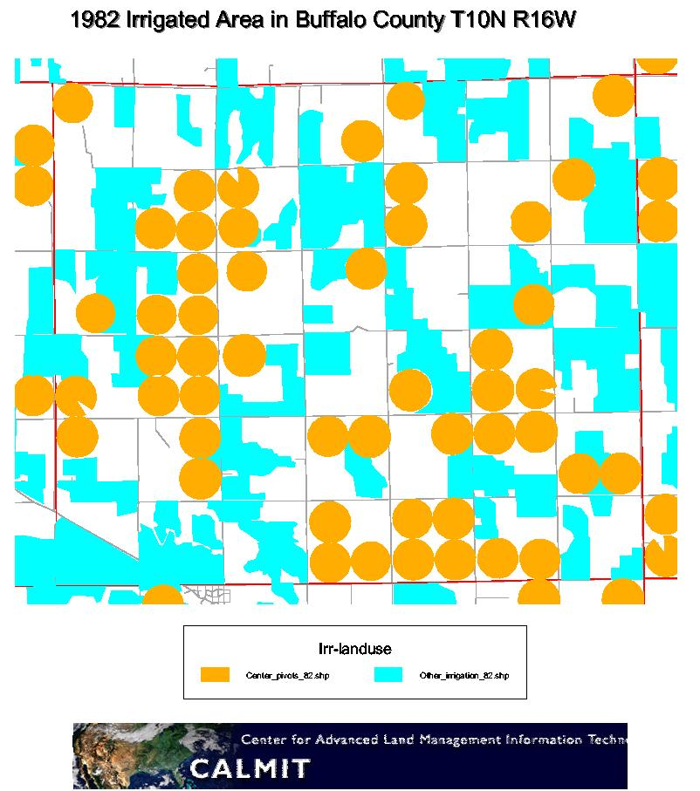
Figure 9. Land Use designation of irrigated land 1982

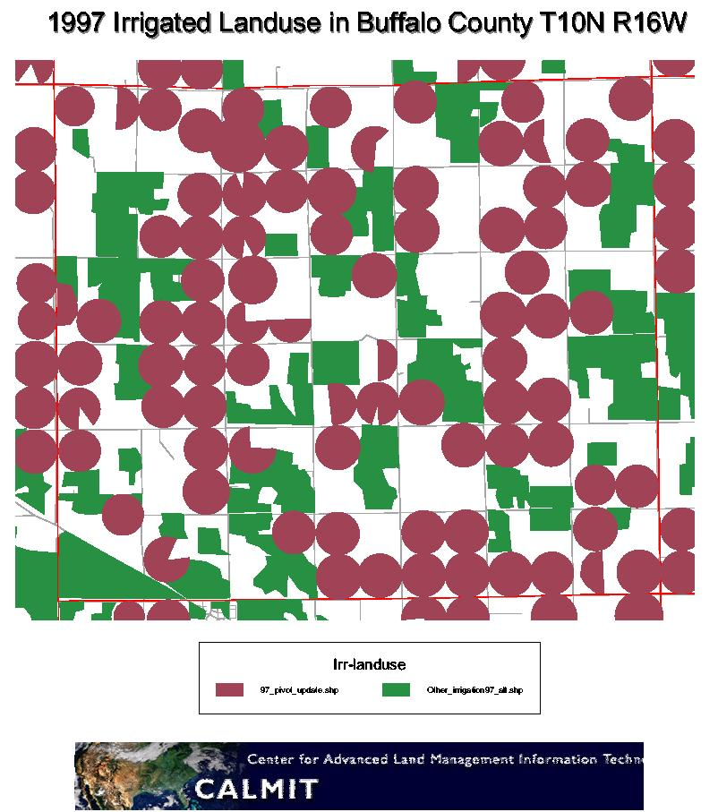
Figure 10. Land Use designation of irrigated land 1997
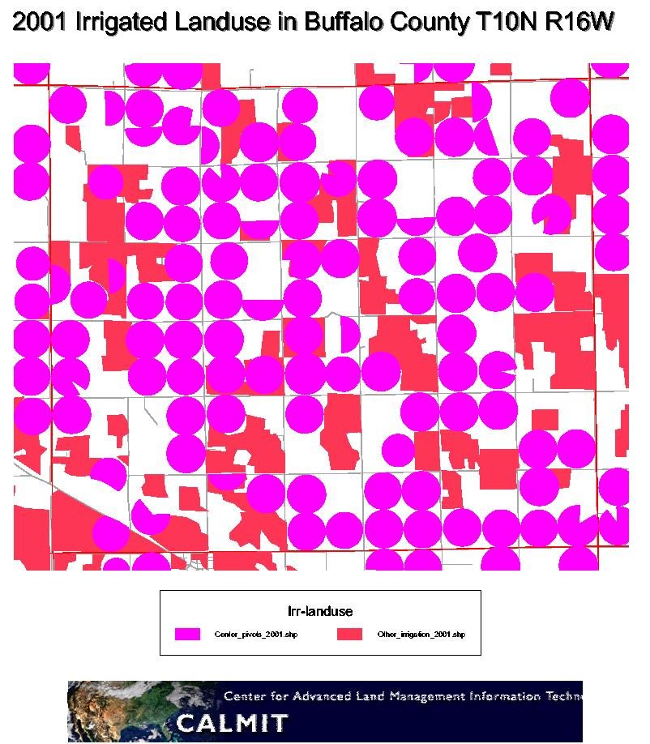
Figure 11. Land Use designation of irrigated land 2001

Climatic Data (Temperature, Precipitation, Wind, Solar Radiation, and Pan Evap)

Daily weather data was assembled for the 39 weather stations shown in figure 12 by the UNL – Ag Engineering Department from the High Plains Climatic Center. These weather data were used by UNL to develop a historic 1949 to 1998 period of daily potential ET. This data was calculated using the Penman Monteith method for the 1980’s and 1990’s where the appropriate data were available and was calculated using a calibrated Blainey Criddle method for the full period 1949 to 1998.

Consumptive Use for Various Land Uses

Using the potential ET data for the 39 weather stations, the soils database, tillage data and crop coefficient information, consumptive use was estimated by crop or land use type (trees, wetlands, corn, soybeans, etc) using a Crop Simulation Model (CROPSIM) developed by the UNL Agricultural Engineering Department. CROPSIM is a daily soil moisture budget model that computes crop ET, field runoff from precipitation, effective rainfall, crop water use, and deep percolation from the soil profile. For each weather station the daily CROPSIM output was summarized for a monthly time series and place into a database. The final CROPSIM runs were made by the Flatwater Group and are described in the report, “Report on Runs for Estimating Crop Water Use and Deep Percolation”.

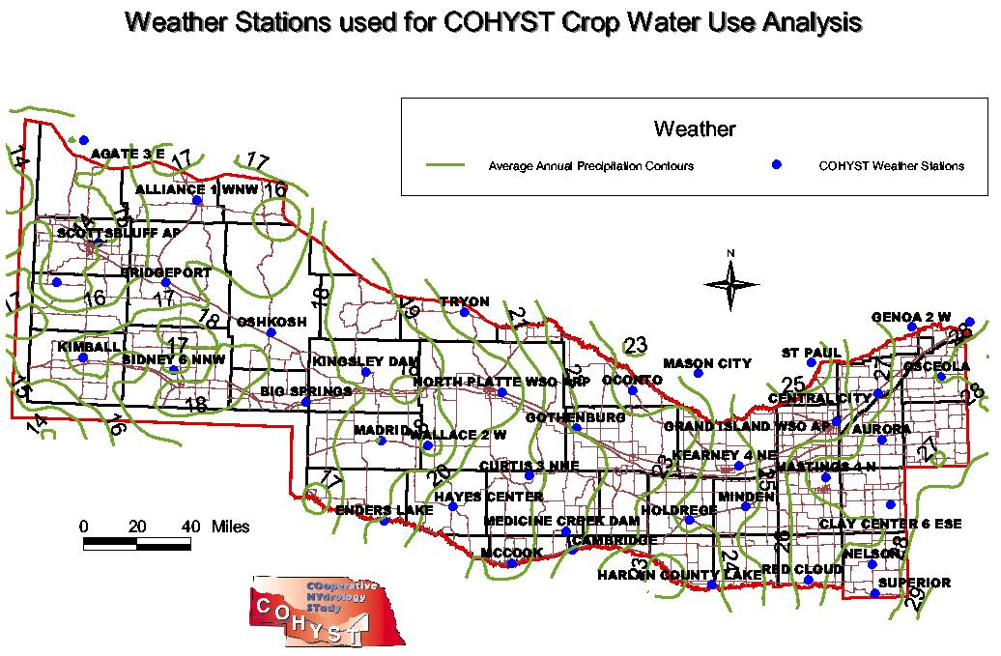
Figure 12. Map showing location of 39 weather stations used for COHYST and average annual precipitation across the area.

Groundwater Recharge (deep percolation of rainfall)

Groundwater Recharge from deep percolation of rainfall was estimated for the COHYST area based on topographic regions see Figure 13. The pre-groundwater development period rainfall recharge was varied within each topographic region based on changes in rainfall across the COHYST area. The Groundwater Model document reports will elaborate on how estimates were made during the calibration process.

For the development period 1950 to 1998 estimates of rainfall recharge were made using the 1950 to1997 spatially distributed land use, the CROPSIM model estimate of 1950 to 1997 deep percolation, and the weather station across the COHYST area (see previous discussions). The detailed process of computing what rainfall is recharge to the groundwater aquifer is shown in the flowchart Figure 14. The flowchart shows four basic processing steps. The red portion displays the steps in developing the spatial land use over time from 1950 to 1997. The green portion shows the steps in applying the CROPSIM output to the process by creating a weighted spatially distributed database for the years 1950 to 1997 based on the location of soils and weather stations. The yellow highlighted steps estimate how model nodes between weather stations are weighted, and the blue portion shows the steps taken to bring together land use acres over time by model node, and weighted CROPSIM data by model node in order to output a time series of spatially distribute rainfall recharge to the groundwater system.

These estimates of rainfall recharge fell short of what was needed to obtain calibrated models so final recharge estimates for the 1950 to 1998 development were made by starting with the pre-groundwater development rainfall recharge estimates by topographic regions across the model area. Then adding additional recharge to dryland and irrigated lands across the model area to obtain model calibration during the development time period. The Groundwater Model document reports will elaborate on how estimates were made during the calibration process.
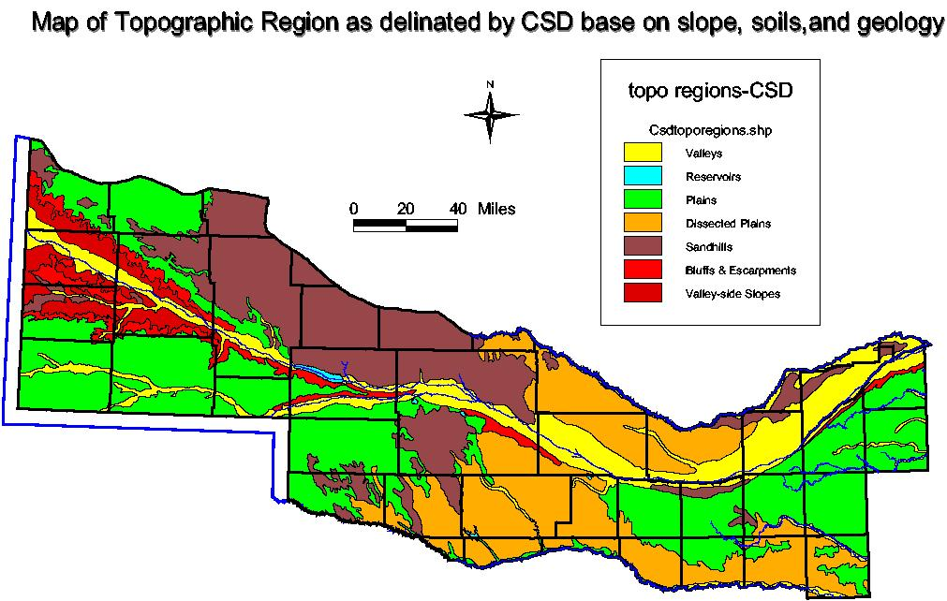
Figure 14. Topographic Regions used for rainfall recharge development

Groundwater Pumping( irrigation, municipal and industrial use for the development period)

Net groundwater pumping for the 1950 to 1998 development period in the COHYST area was estimated using crop irrigation requirement (CIR) for irrigated crops using the UNL CROPSIM model as described in the consumptive use section above. The same process as discussed above for CROPSIM recharge was used to distribute it spatially through time.

A second net groundwater pumping dataset was developed for the COHYST area called the Neb-Guide pumpage. It used seasonal average annual crop water use estimates from the 1990 Neb-Guide title “Evapotranspiration (ET) or Crop Water Use” and CROPSIM effective precipitation for the same season to estimate seasonal crop irrigation requirement or net groundwater pumping.

Both methods have been used in the model calibration process see model reports for discussion.

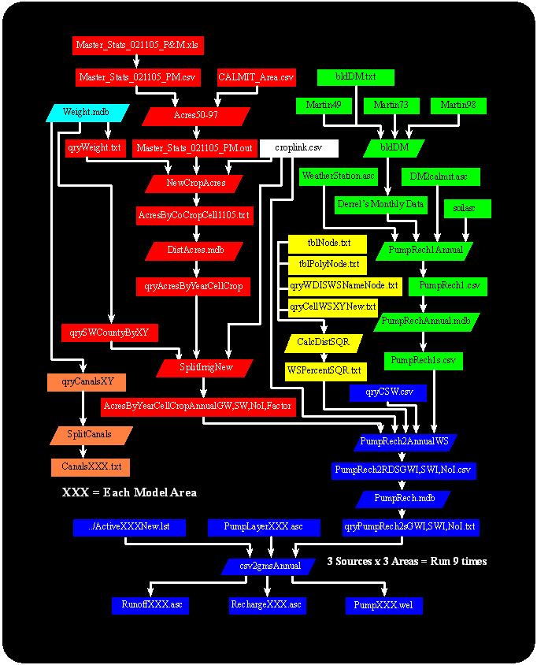
Figure 14. Flowchart of Process used to Estimate Groundwater Pumpage and Recharge

Groundwater Recharge (canal seepage, and reservoir seepage)

Canal seepage was estimated for each major surface water project in the COHYST study area. Many of the estimates were developed from diversion records and farm delivery records recorded by the irrigation districts or U.S. Bureau of Reclamation Water Supply Reports. For the surface water projects in the Panhandle these estimates had already been made and publish in the North Platte River Return Flow Study & Model report by Bishop Brogden Associates Inc. January 2002. The Groundwater recharge from canal seepage is discussed in more detail in the Model documentation reports.

Reservoir seepage for some of the smaller reservoirs was estimated along with the canal seepage for the system. Seepage from larger reservoir was developed and included in the models see model documentation for how it was done.

Develop and Calibrate Ground water Models as usable Tools for performing Groundwater Analysis

Flow Modeling Strategy for COHYST

The Cooperative Hydrology Study (COHYST) flow modeling strategy describes how models of the groundwater flow system within the Platte River Basin in Nebraska were developed. Several hydrogeologist have developed a number of flow models based on the documented strategy to help make the models consistent with each other across the model areas. This strategy initially was a blueprint to build the models. The strategy talk of developing small, river valley models before the regional models were developed. This concept was dropped as the regional models were developed and ran easier than expected. Also the strategy did not cover the details of the 1950 to 1998 development period calibration that was implemented.
The overall strategy is to start simple and add detail to the model as required. The detail of some of the data sets developed for the COHYST study allows this strategy to be pursued. If the added detail does not improve the fit between observed and simulated water levels or groundwater discharges to and from streams, the added detail will not be used in the model. For example, the model may begin with a uniform value for hydraulic conductivity within a layer. After the best value for hydraulic conductivity has been determined for each layer, some areal distributions of hydraulic conductivity for the layer may be tested. If an areal distribution improves model fit, it will be retained; if it does not, it will not be used in the model.

The overall area modeled was subdivided by a series of north-south lines into modeling units. The modeling units overlap by at least 12 miles. Within the areas of overlap, an effort has been made to make both simulated water levels and simulated groundwater flows to or from streams consistent between the modeling units. However, it was impossible to make simulated water levels and flows match exactly, so some small differences were tolerated. Narrative descriptions of the differences are discussed in the model reports.

Ideally, the flow models should start modeling a period prior to any surface-water or groundwater development when natural inflows were in dynamic equilibrium (steady state) with natural outflows. However, the groundwater system received a major perturbation as early as 1890 when water was first diverted into what is now the Tri-State Ditch along the North Platte Valley in the western part of the study area. It is impractical to attempt to formally calibrate a model for the period prior to 1890 because of lack of information. However, the groundwater system may have been in equilibrium with the long-term effects of these early canals long before substantial groundwater pumpage for irrigation began. This period after the system was in equilibrium with surface-water irrigation and before substantial groundwater irrigation is considered to be the best starting model period because an equilibrium plateau from surface-water irrigation probably was reached in most areas, and because data collection was initiated at about the same time.
To evaluate system equilibrium a series of steady state simulations were made, the first steady state run was before development, a second one was made with early surface water canal development above Kearney, NE, a third one was made with the addition of Lake MacConaughy, and Central Nebraska Public Power and Irrigation District system about 1940. Then the final steady state period run was to 1950 when groundwater development started.
The start of major groundwater development for irrigation is defined to be 1950. Very little groundwater development occurred prior to this date except where the depth to water was very shallow. Much of the groundwater development outside the valleys occurred much later.
Nebraska Public Power District and the Central Nebraska Public Power and Irrigation District began to operate large canals in the central and eastern modeling units in the late 1930s. It is fairly certain the groundwater flow system had not come back into dynamic equilibrium by 1950 in areas with these large canals and their associated surface-water irrigation. Simulation of the pre-groundwater development period in the modeling units where this occurred were developed to include the effects of these canal systems.

In addition to the pre-groundwater development modeling strategy there are transceint regional groundwater models being calibrated for the groundwater development period. The time period used for calibration of these models are the years 1950 to 1998 with 2 seasonal time steps of May thru September and October thru April.

The models were constructed with progressively finer grids to improve the quality of the model results. Given the time available for the COHYST project, three generations of grids were used in the process of model development (2 mile, 1 mile and ½ mile). However, the strategy was to look to the future, so some data were developed that may not be used in the present study, but may be useful to future, more detailed studies.
The regional models were originally constructed using a coarse 2 mile grid that captured the essential features of the groundwater flow system within the modeling unit. The coarse grids minimized the number of cells to allow the model to be conceptualized, constructed, and run quickly. The 2 mile regional models were approximately calibrated, that is, calibration was stopped when there is general agreement between observed and simulated conditions. The models were then re-constructed to the 1 mile grid model to improve model refinement and calibration. The final regional models are the ½ mile grid models.
To construct data sets that will support the various levels of resolution desired, the entire COHYST study area was gridded with hierarchical set of grids as follows:
Grid spacing | Cell area | Approximate number  of cells, including  inactive cells outside the COHYST area
2 miles | 4 square miles | 4,000
1 mile | 1 square mile | 16,000
0.50 mile | 160 acres | 65,000
0.25 mile | 40 acres | 260,000
0.125 mile | 10 acres | 1,000,000

The initial models were first constructed as single-layer models using published RASA data for the bottom of the aquifer. As the Hydrostratigraphic Units describe above were completed, multiple layers were added to the 1 mile regional Models to help define the groundwater flow system and improve the model calibration.
Calibration consists of systematically varying uncertain model inputs within reasonable ranges to make simulated water levels and groundwater discharges to and from streams match observed conditions. Model inputs will be varied over large areas within ranges supported by known or suspected geologic and hydrologic conditions.

Regional Groundwater Models Developed and Calibrated for the COHYST Area

For this current phase of the COHYST study the regional groundwater flow models to be developed and calibrated are the ½ mile grid steady state pre-groundwater development period models and ½ mile grid transient development period models for the Eastern Model unit, the Central Model unit and Western Model unit. Throughout the development and calibration process these models have been documented for inclusion into a final report. There will be a modeling report for each model unit. The model reports will use a similar format that includes the following information.
- A description of the overall COHYST area including the aquifer system.
- A discussion of the modeling strategy as presented in the previous section.
- A detailed description of the Modeling Unit. Like boundaries, counties, NRDs, cities, towns, landscape of region, land use within region, river and tributaries that drain the region, land surface elevations across the area, general weather summaries for the area, etc.
- Each report includes a conceptual flow model discussion that describes the characteristics of the groundwater flow system. The conceptual model includes the state of the flow system at the beginning of the simulation period, the lateral and vertical boundaries of the model, what happens to the flow of water at these boundaries, and how the flow system interacts with external sources and sink of water.
- The reports include a major section on numerical model construction where the model assumptions and intended use of the model are laid out. Where the numerical techniques of a computer program are describe as to how they represent a groundwater flow system. Where the model grid is described and input datasets explained.
- The reports also includes a major section on numerical model calibration were the process of systematically adjusting selected model inputs within reasonable limits is described in relation to the comparison of computed versus observed data. The model inputs adjusted during calibration included hydraulic conductivity, specific yield, bed conductance, recharge, and pumpage. These inputs were adjusted both temporally and spatially for the calibration process.
- A section of the report discusses the quantitative analysis of model calibration. This section presents the commonly compared simulated water level versus observe water level statistics. It also discusses the comparison of simulated base stream flow and observed base stream flow.
- The reports included a discussion on model sensitivity and limitations.
- They also included a discussion on comparison of adjacent models. Compared are simulated water levels, stream discharge, recharge values, and hydraulic conductivity.

Each of the model reports as documented presently, with figures and tables are less then 100 pages.

COHYST Products

There have been a number of products developed as part of the COHYST study. They include work plans, reports, databases, data interpolations, and models or tools. Many of these products were referred to in the discussion of the Study Process above. Many of these products are posted on the COHYST website at http://cohyst.dnr.state.ne.us/.

The following is a outline of those products develop as part of the COHYST study by subgroup.

Model Products
Western Model Unit report
Central Model Unit report
Eastern Model Unit report
Western Model Unit GMS-MODFLOW ½ mile steady state and transient calibrated models
Central Model Unit GMS-MODFLOW ½ mile steady state and transient calibrated models
Eastern Model Unit GMS-MODFLOW ½ mile steady state and transient calibrated models
Calibration Products
Estimated Groundwater Discharge to Streams from the High Plains Aquifer in Western Model Unit
Estimated Groundwater Discharge to Streams from the High Plains Aquifer in Central Model Unit
Estimated Groundwater Discharge to Streams from the High Plains Aquifer in Eastern Model Unit
Pre-development observed groundwater levels
Post-development observed groundwater level changes
Data Products
COHYST Hydrostratigraphic Units and Aquifer Characterization report
GIS riverbed conductance measurement data
GIS river and tributary bed elevation data and stream stage data
Tabular datasets of CROPSIM and Neb-Guide Net groundwater pumpage for irrigation
Tabular datasets of CROPSIM estimated rainfall recharge by land use type
External Products developed for COHYST
County Testhole Log books by UNL Conservation and Survey Division
Delineation of Land Use Patterns 1982, 1997, 2001, by UNL CALMIT section of CSD
Comparison of Instream Methods for Measuring Hydraulic Conductivity in Sandy Streambeds by USGS Landon, Rus, and Harvey
Vertical Profiles of Streambed Hydraulic Conductivity determined using Slug Test by USGS Rus, McGuire, Zurbuchen, and Zlotnik
Crop Simulation Model development and runs by UNL Agricultural Engineering Department Dr. Derrel Martin
CROPSIM Update and Scenario Report by The Flatwater Group Inc. Marc Groff
Platte River Riparian ET Study in progress by USGS Matt Landon study coordinator

